1. Firstly open a new unity project, ensure you name the project with a clear file name. You will have to select 2D or 3D:

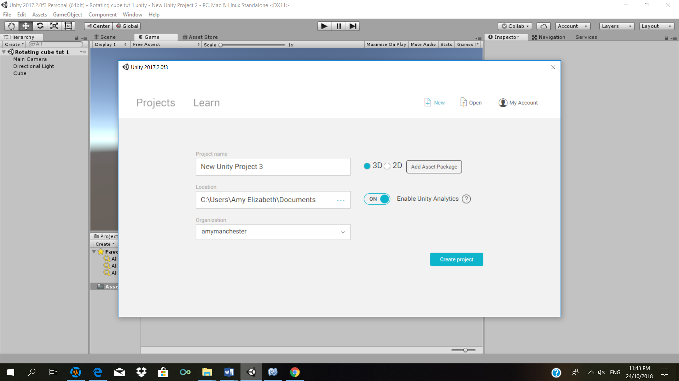

Select whichever one is your preference, as this will not effect the code.

2. Secondarily, create a game object, depending on whether you have created a 2d or 3d game and what shape you prefer.

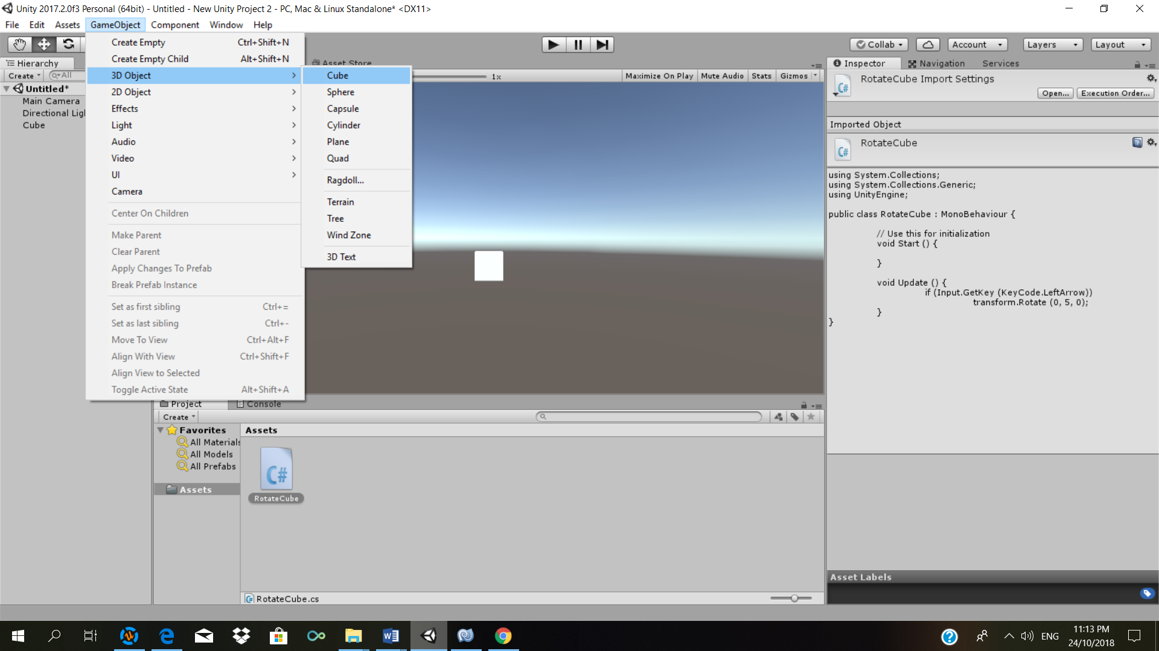

3. Once you have selected a game object, you can now begin to write the code. In order to do this you must select Create, Assets, C# script. Ensure you name the script clearly so you know what the script is there for:

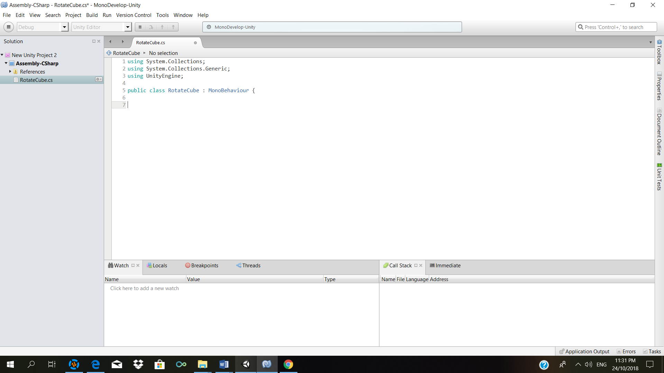

4. You can now begin to create your code, (text show in red explains what the code means):

public class RotateCube : MonoBehaviour {

// Use this for initialization

void Start () {

}

void Update () {

if (Input.GetKey (KeyCode.LeftArrow)) *// This if statement states that when the left arrow is pressed, the cube will rotate on the axis 0,5,0*

transform.Rotate (0, 5, 0);

}

}

5. After writing the code, press f4, the system will then run build your code and will inform you if there are any errors or bugs.

6. Now simply drag the script onto the gameobject you previously created in step 2, you will now see your object moving when selecting the left arrow!